Part 1

Questions
- Describe the location of the business

- Tell me when the business was set up? (Year)

- What the business sells? (Products/services/both)

- Describe the purpose and the aims of the business and its objectives (eg- to make a profit- be the best in the area, continue with a family run business)

Answers

My chosen business is Hidden Escapes. This business is a health and beauty salon.

The outside of Hidden Escapes

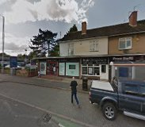

Logo of the business
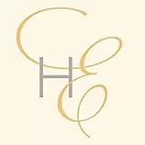

The purpose and aims of my business

Hidden escapes is located in Penn Wolverhampton in the West Midlands. It is situated above a hair salon along a main road next to a small row of shops, and opposite a small arcade of shops.

Hidden Escapes was founded in 2018 and was set up as a partnership. This business sells tangible beauty products from the ‘Elemis range’ which is a high end beauty product. It also provides services through a number and variety of beauty treatments to include non surgical face and body treatments. They sell beauty packages and vouchers for customers to buy as gifts. Therefore it sells both products and services.

The aim of the business is to provide a high end quality product to its customers and to provide luxury treatments. These are branded products and they are stockists of : Decleor Skincare, SkinBase Microdermabrasion, CND Shellac & Nail Extensions, Fake Bake Tanning, Flirties Lash lift & Lash Extensions, Lava Shell Massage by Secret Beauty.
​
They provide therapists that are highly trained and qualified to a minimum of NVQ Level 3 in Beauty Therapy and pride themselves in providing excellent​ beauty treatments in luxury surroundings to make sure that their customers have a ‘truly relaxed’ experience. They provide excellent customer service and welcome customers to hide, escape and unwind.
​

